WEB
- FIX THE ANIMATION!
- CHANGE THE AWARD WINNING PROJECTS TO SLIDES (instruction on miro)
IMPLEMENT INVESTMENT OPPORTUNIES (miro)
- Both quotes thicker
- Both quotes on central axes
- Delete buyer support, put it inside property portfolio (detailed instruction on miro, (visualisation the squares) deleted to make everything easier)
- Add “contact our team” button in the very bottom section of all of the pages (miro)
- Add languages in the top right corner (English, Chinese, Polish, Spanish, Italian, French, German)
- Link instagram
- Link LinkedIn
MOBILE
- Award winnig adjusted to mobile like franek send screenshot
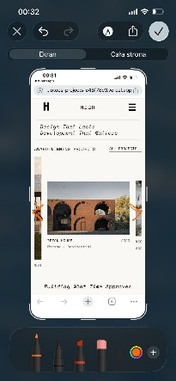
- About us -> 4 people next to each seeable at first load,
not 1,5 like now
- To quote from topp remove
- To quote were is rn: “we build what time approves”, change to : Design that lasts, development that matters
- The quote: : “we build what time approves,” put under the team section 